Press Release: Richard Bangs’ Adventures with Purpose
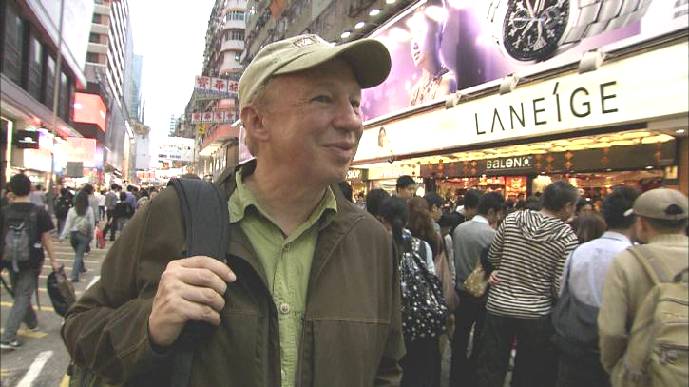
Richard Bangs’ Adventures with Purpose—Hong Kong: Quest for the Dragon, a new, one-hour special from American Public Television, will air on _________ (station) _________________ at (time) _______, (day) __________ (date) _________. Hosted by Richard Bangs who is often called “the father of modern adventure travel,” Hong Kong: Quest for the Dragon is the latest documentary in a series of adventure travel, eco-conscience, and historical specials. According to Bangs, “Adventures with Purpose not only quicken the pulse and fire the synapses, they are also journeys of enlightenment and discovery—odysseys that make a difference.”
Adventures with Purpose is produced by Small World Productions, the makers of Smart Travels—Europe and Pacific Rim with Rudy Maxa and Travels in Europe with Rick Steves. The specials are co-produced by KCTS/Seattle, and Richard Bangs Productions of Marina del Rey, California. KCTS is the presenting station to APT.

This time Richard Bangs journeys through a city that blazes like a great pageant of light…a land of giants in both steel and dreams…a place that pushes the limits of the possible…and not so much predicts the future, as invents it.

Why is Hong Kong so prosperous, so energized, so vital, so cutting edge? What makes it the city of the century, the city of tomorrow? It’s not geography; there are spectacular harbors and islands—too many to count—that never spawned such a city. It’s not latitude—many lesser cities share its position on the globe. As Rudyard Kipling said, “Hong Kong beats into a hamlet” other great cities of the world. Richard’s quest this time is to discover what unique forces drive Hong Kong to virtuosity and greatness.


Hong Kong’s uninhibited energy is clear as rice wine….in its corridors of commerce…in its seething alleys of ancient apothecaries…in its earthly rhythms and promethean spirit. What cultural undercurrent runs through this miracle city? What age-old traditions galvanize the fierce devotion to work and family here? To what can we attribute their longevity, health, their unparalleled triumphs against enormous odds, and even their seemingly paradoxical success with environmental protection? Could the answer lie in a legend as old as the land itself?

Richard’s quest takes him from the towering structures in Central and Western Hong Kong and then across the hive-like Victoria harbor to the Kowloon peninsula. He sails to the ecological preserve, the Geo-park and to Lantau Island.

Hong Kong’s allure is unquestionable and unanswerable, from its cloud-busting buildings and exuberant festivals, to its serene shorelines and roar of nighttime neon. Hong Kong belies Kipling’s thesis that “never the twain shall meet.” It began as a collection of quiet fishing villages, but found its voice and métier 150 years ago as nexus for trade between East and West. While the population is overwhelmingly
Richard Bangs’ Adventures with Purpose
Hong Kong: Quest for the Dragon
Press Release, Page 2

Chinese, the fusion of styles and sensibilities from around the world makes this an intoxicating cocktail of cultures.

Here—more intimately than anywhere else—civilizations have been thrown together. But two fundamentals stay constant yet in healthy dialectic: the reverence for tradition, and the fierce pursuit of prosperity.

Some say that to understand the heart of Hong Kong one must 'look to the Dragon.’ So, Bangs is in Hong Kong for the most dazzling festival on earth, Chinese New Year, when the vital, flowing energies of the Dragon inhabit the jungles of the imagination; when the pyrotechnics awaken the good beasts and usher in a new beginning.

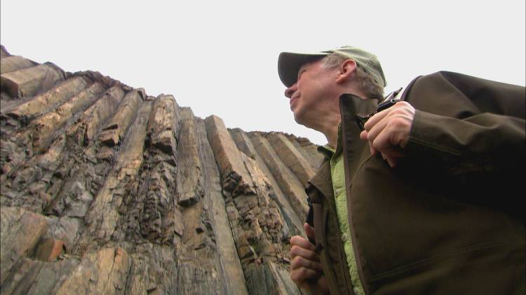
Host and co-executive producer, Richard Bangs is a pioneer in travel that makes a difference, travel with a purpose. He has spent more than 30 years as an explorer and communicator, and along the way led first descents of 35 rivers around the globe, including the Yangtze in China and the Zambezi in Southern Africa. Richard has published more than 1000 magazine articles, 18 books, a score of documentaries and CD-ROMs; and has lectured at the Smithsonian, the National Geographic Society, the Explorers Club and many other notable venues. He writes a semi-regular feature for the NY Times. His latest books include Adventures with Purpose, Quest for Kaitiakitanga, Quest for the Sublime and Quest for the Kasbah, companion books for episodes in the television series.

Richard’s books and DVDs of Adventures with Purpose—Hong Kong: Quest for the Dragon are available from Small World Productions. Each DVD contains the complete show and more than two-hours of value-added bonuses: Richard’s adventure travel tales, never-before-seen footage, and behind-the-scenes glimpses. DVDs are $24.95 each plus shipping. Richard’s Adventures with Purpose books are $16.95 each plus shipping. Books include essays by Richard on a number of destinations. A transcript of the Hong Kong show is included with book orders free of charge. The book and DVD together are $35.95 plus shipping. Viewers may order online at www.AdventuresWithPurpose.TV or call the order desk at 800.866.7425.

Small World Productions, Inc. of Seattle produces Richard Bangs’ Adventures with Purpose. KCTS/Seattle and Richard Bangs Productions are co-producers. KCTS is the presenting station.

An HDTV version of Adventures with Purpose—Hong Kong: Quest for the Dragon will up-link on APT’s HD satellite transponder. The standard definition “letterboxed” version will air on hundreds of public TV stations nationwide. Digital audio is transmitted in stereo.

American Public Television (APT) has been a leading distributor of high-quality, top-rated programming to America’s public television stations since 1961. In 2009, APT distributed 56 of the top 100 highest-rated public television titles. Among its 300 new program titles per year are prominent documentaries, dramatic series, how-to programs, children’s series and classic movies, including Spain...on the road Again, Rick Steves' Europe, Newsline, Globe Trekker, Simply Ming, America's Test Kitchen From Cook’s Illustrated, Lidia's Italy, P. Allen Smith's Garden Home, Murdoch Mysteries, Doc Martin, Rosemary and Thyme, Johnny Cash at Folsom Prison, Liza’s at the Palace…. and John Denver: The Wildlife Concert. APT also licenses programs internationally through its APT Worldwide service. In 2006, APT launched Create™ – the TV channel featuring the best of public television's lifestyle programming. For more information about APT’s programs and services, visit APTonline.org.

Support for the production of this documentary special is provided in part by United Airlines and United Vacations.com.

